Chapter 7, Problem 39.

Calculate the capacitor voltage for t < 0 and t > 0 for each of the circuits in Fig. 7.106.

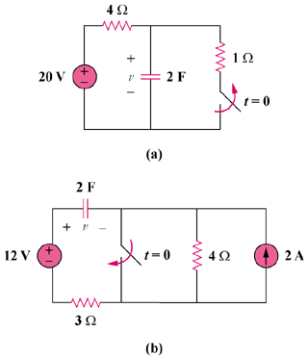

Figure 7.106
For Prob. 7.39.

